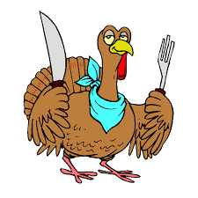NOVEMBER 2020
USDA is an equal opportunity provider and employer | ½ Pint of Milk offered Daily-  1% WHITE, 1% CHOCOLATE, AND SKIM STRAWBERRY | A variety of vegetables and fruits offered daily on the salad bar.  Selections subject to change.
2  HOT DOG  CHILI/ CHILI DOG  GREEN BEANS  PEARS | 3  GRILLED CHICKEN  ALFREDO PASTA  PEAS  PEACHES | 4  BEEF NACHOS  FAJITA CHICKEN  BLACK BEAN TACO FIESTA  ORANGES  SALSA/CHIPS | 5  CRISPITO  RIB PATTY SAND.  CARROTS  PINEAPPLE | 6  PIZZA  CHICKEN NUGGETS  CORN  FRUIT COCKTAIL  CRACKERS
9  CHEESEBURGER  CORNDOG  SMILEY FF  PEARS | 10  POPCORN CHICKEN  BOSCO STICK  GREEN BEANS  PINEAPPLE/BANANA  CRACKER | 11  CHICKEN & NOODLES  MASHED POTATOES  CORN  PEACHES  HOT ROLL | 12  PORK FRITTER SAND.  PIZZA BURGER  PEAS  MANDARIN ORANGES | 13  SUB  PEPPERONI POCKETS  CUCUMBERS/LETTUCE  APPLESAUCE
16  TOASTED CHEESE SAND.  TOMATO SOUP  FRENCH BREAD  PEACHES | 17  HOT HAM & CHEESE SAND.  SHRIMP POPPERS/COTTAGE CHEESE  RAISELS  APPLESAUCE  CRACKERS | 18  PIZZA  CHICKEN SAND.  PEAS  PEARS | 19 THANKSGIVING DINNER  TURKEY GRAVY  MASHED POTATOES  GREEN BEANS  PUMPKIN CUSTARD  BAKED APPLES  HOT ROLLS | 20  WRAP  RAVIOLI  CORN  PINEAPPLE
23  COOKS  CHOICE | 24  COOKS  CHOICE | 25  NO SCHOOL | 26  NO SCHOOL  THANKSGIVING BREAK | 27  NO SCHOOL  THANKSGIVING BREAK
30  SWEET THAI CHILI CHICKEN  BEEF TERIYAKI DIPPER  SWEET RICE  CARROTS  PINEAPPLE | 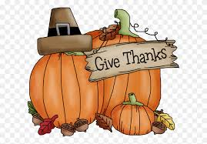
MONDAY TUESDAY WEDNESDAY THURSDAY FRIDAY

